CREATE VIEW

1-

CREATE VIEW forFood AS SELECT Food_ingr,Food_Name FROM Food

SELECT*FROM forFood

WHERE Food_ingr LIKE ('%Tomato%')

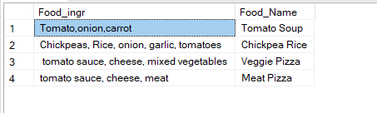

2-

CREATE VIEW vw_cusmail AS SELECT Cus_Name,Cus_Lname,Cus_Email FROM Customer

ALTER VIEW vw_cusmail AS SELECT Cus_Name,Cus_Lname,Cus_Email,Cus_PhoneNumber FROM Customer

SELECT Cus_Email,Cus_PhoneNumber FROM vw_cusmail

WHERE Cus_Email='trabzon61@gmail.com'

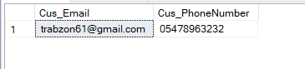

3-

CREATE VIEW vw_Order AS SELECT Order_ID,Order_Amount FROM Ordering AS ord

JOIN Food AS fdd ON ord.Food_ID=fdd.Food_ID

ALTER VIEW vw_Order AS SELECT Order_ID,Order_Amount,Food_Name FROM Ordering AS ord

JOIN Food AS fdd ON ord.Food_ID=fdd.Food_ID

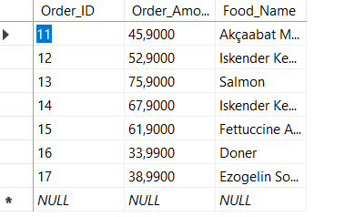

SELECT Order_Amount,Food_Name FROM vw_Order

WHERE Order_Amount<60

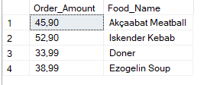

4-

CREATE VIEW vw_rat AS SELECT Food_Name,Comments FROM Rating

AS rat JOIN Food AS fdd ON rat.Food_ID=fdd.Food_ID

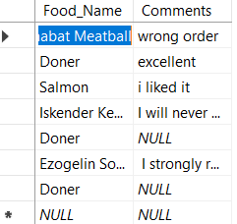

SELECT * FROM vw_rat

WHERE Comments IS NOT NULL

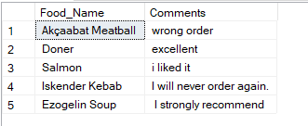

5-

CREATE VIEW vw_Coupon AS SELECT Coupon_ID,Coupone_Amount FROM Coupon AS C

JOIN Restaurant AS res ON res.Res_ID=C.Res_ID

ALTER VIEW vw_Coupon AS SELECT Coupon_ID,Coupone_Amount,Res_Name FROM Coupon AS C

JOIN Restaurant AS res ON res.Res_ID=C.Res_ID

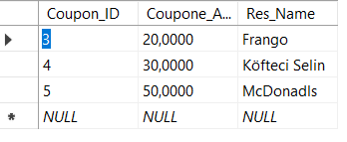

SELECT Res_Name FROM vw_Coupon

WHERE Coupone_Amount=20

